**Instructions for MX values and Actual Split Percentage Analysis**

**Step1:** Go to SCATS History Viewer to the Event tab (for MX Values) and Phase tab (for Actual Split %) and select the specific date and site then export the results as csv file (as shown below)

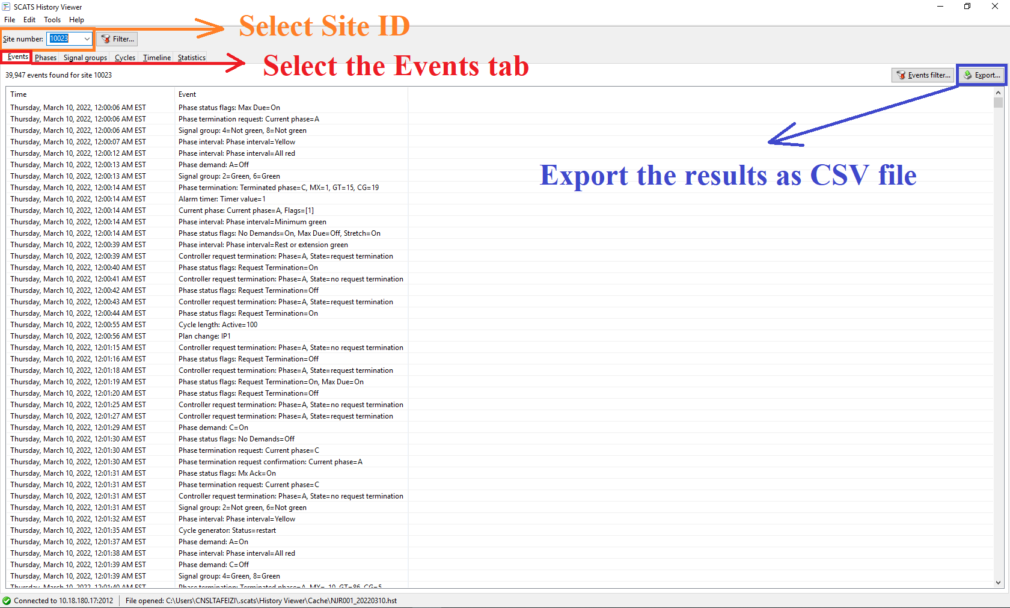

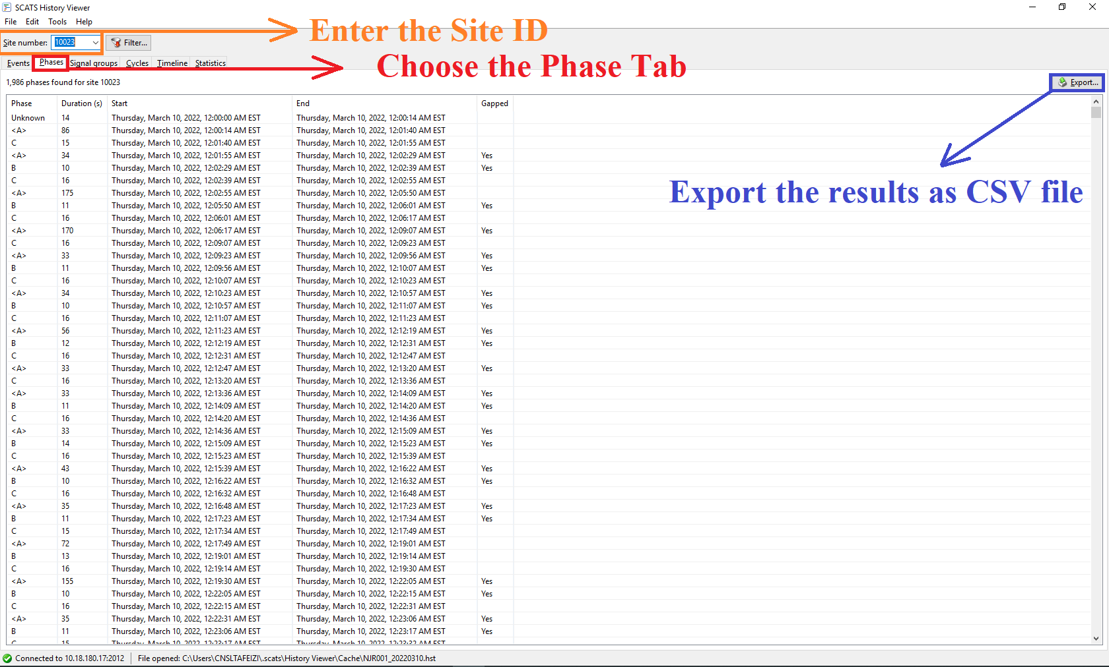

**Step2:** Choose on the website the Site ID, the time boundaries as indicated in the image below

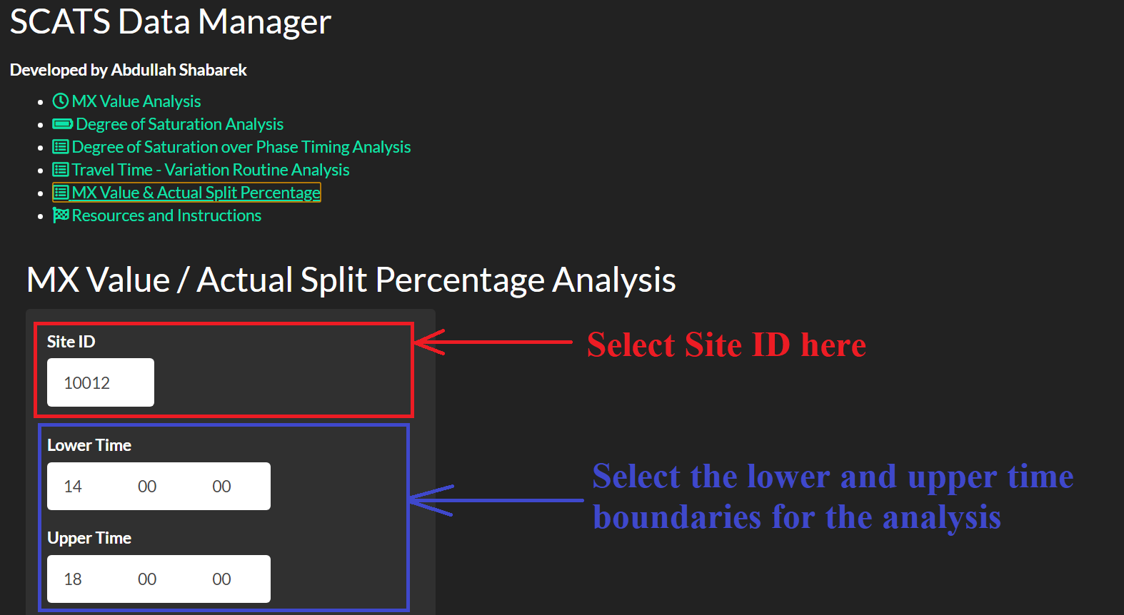

**Step3:** Upload the files and specify the phase for MX value analysis as indicated below:  
